**ON JOB TRAINING REPORT**

(Project Term January-May 2019)

On

**Project Name: NETA App**

**Organization**



**Submitted By**

**NAME: Ms. Kalpana Prakash**

**REGISTRATION NUMBER:** 11508638

Bachelor of Technology in Computer Science and Engineering

**Under the guidance of**

Praveen Kumar, Lead Infra Architect – Enterprise Compute and Cloud Services (ECCS)

**School of Computer Science and Engineering**



**DECLARATION**

I hereby declare that the project work entitled (“NETA – Leaders ka Report Card”) is an authentic record of our own work carried out as requirements of Internship Project for the award Bachelor of Technology in Computer Science and Engineering from Lovely Professional University, Phagwara, under the guidance of Mr. Praveen Kumar, during January 2019 to May 2019. All the information furnished in this internship project report is based on our own intensive work and is genuine.

Name of Student: Kalpana Prakash

Registration Number: 11508638

(Signature of Student)

Date:

**CERTIFICATE**

This is to certify that the declaration statement made by the student is correct to the best of my knowledge and belief. They have been a part of this Internship Project under my guidance and supervision. The present work is the result of their original investigation, effort and study. No part of the work has ever been submitted for any other degree at any University. The Internship Project is fit for submission and partial fulfillment of the conditions for the award of B.Tech degree in Electronics and Communication Engineering from Lovely Professional University, Phagwara.

**Signature and Name of the Mentor**

**Designation**

**School of Computer Science and Engineering,**

Lovely Professional University,

Phagwara, Punjab.

Date:

`**ACKNOWLEDGEMENT**

I have done efforts during this Internship. However, it would not have been possible without the kind support and help of many individuals. I would like to extend my sincere thanks to all of them.

I am highly indebted to Mr. Praveen Kumar, Lead Infra Architect for their guidance and constant supervision as well as for providing necessary information regarding my problems and doubts & for their support in completing the project and internship.

I would like to express my gratitude towards my parents & members of Cognizant for their kind co-operation and encouragement, which help me in completion of this project. My thanks and appreciations go to my colleague in developing the project and people who have willingly helped me out with their abilities.

Regards,

Kalpana Prakash (11508638)

**TABLE OF CONTENTS**

1. **ORGANIZATION OVERVIEW………………………………………………...……………………………6**
   1. **ABOUT VENTUREPACT LLC…..……………………………………………………………………7**
   2. **VISION AND MISSION OF COMPANY…………………………………..…………………………8**
   3. **SERVICES……………………………………………………………………………………………...9**
2. **ABOUT NETA APP…………………………………………………………………………………………11**
3. **INTRODUCTION…………………………………………………………………………………………...12**
4. **SCOPE OF STUDY…………………………………………………………………………………………14**
5. **EXISTING SYSTEM………………………………………………………………………………………..15**
   1. **EXISTING SYSTEM………………………………………………………………………………….15**
   2. **WHAT’S NEW IN THE SYSTEM …………………………………………………………………...15**
   3. **DFD FOR PRESENT SYSTEM ……………………………………………………………………...16**
6. **PROBLEM ANALYSIS…………………………………………………………………………………….21**
   1. **PRODUCT DEFINITION……………………………………………………………………………..21**
   2. **FEASIBILITY ANALYSIS…………………………………………………………………………...21**
   3. **PROJECT PLAN……………………………………………………………………………………...23**
7. **SOFTWARE REQUIREMENT ANALYSIS…………………………………….………………………...24**
   1. **INTRODUCTION…………………………………………………………………………………….24**
   2. **SPECIFIC REQUIREMENT…………………………………………………………………………24**
8. **DESIGN …………………………………………………………………………………………………....26**

**8.1 SYSTEM DESIGN……………………………………………………………………………………..26**

**8.2 DESIGN NOTATIONS………………………………………………………………………………...26**

**8.3 DETAILED DESIGN…………………………………………………………………………….…....27**

**8.4 FLOWCHART……………………………………………………………………………………...…28**

**9. TESTING…………………………………………………………………………………………………..29**

**9.1 STRATEGIC APPROACH FOR TESTING………………………………………………………….29**

**9.2 FUNCTIONAL TESTING…………………………………………………………………………….30**

**9.3 STRUCTURAL TESTING…………………………………………………………………………....30**

**9.4 LEVEL’S OF TESTING………………………………………………………………………………31**

**9.5 TESTCASES……………………………………………………………………………………….....32**

**10. LEARNING EXPERIENCE………………………………………………………………………………33**

**10.1 MS EXCEL…………………………………………………………………………………………..33**

**10.2 PYTHON FOR DATA SCIENCE………………………………………………………………......36**

**10.3 PYTESSERACT……………………………………………………………………………………..43**

**10.4 WEB SCRAPING……………………………………………………………………………….......45**

**10.5 ASSEMBLY CONSTITUENCY MODEL………………………………………………………….46**

**11. PROJECT LEGACY……………………………………………………………………………………….47**

**11.1 CURRENT STATUS OF APP………………………………………………………………………47**

**11.2 FUTURE PLANS……………………………………………………………………………………47**

**ORGANIZATION OVERVIEW**

**ABOUT COGNIZANT**

**Cognizant** is an American multinational corporation that provides IT services, including digital, technology, consulting, and operations services. It is headquartered in Teaneck, New Jersey, United States. Cognizant is included in the NASDAQ-100 and the S&P 500 indices. It is also one of the fastest growing Fortune 0 companies. It was founded as an in-house technology unit of Dun & Bradstreet in 1994, and started serving external clients in 1996.

After a series of corporate splits and restructures of its parent companies there was an initial public offering in 1998[4] Following the Y2K and dot-com boom of the late 1990s, when companies sharpened their focus on hard business parameters such as revenues and profits, the company grew by delivering critical application development and maintenance services.

Cognizant had a period of fast growth during the 2000s, becoming a Fortune 500 company in 2011. In 2015, the Fortune magazine named it as the world's fourth most admired IT services company. In 2017, Cognizant was named in Fortune's Future 50 list.

History:

Cognizant began as Dun & Bradstreet [Satyam](https://en.wikipedia.org/wiki/Mahindra_Satyam) Software (DBSS), established as [Dun & Bradstreet](https://en.wikipedia.org/wiki/Dun_%26_Bradstreet)'s in-house technology unit focused on implementing large-scale IT projects for Dun & Bradstreet businesses. In 1996, the company started pursuing customers beyond Dun & Bradstreet.

In 1996, Dun & Bradstreet spun off several of its subsidiaries including Ericson, IMS International, [Nielsen Media Research](https://en.wikipedia.org/wiki/Nielsen_Media_Research), [Pilot Software](https://en.wikipedia.org/wiki/Pilot_Software), Strategic Technologies and DBSS, to form a new company called Cognizant Corporation. Three months later, in 1997, DBSS renamed itself to Cognizant Technology Solutions. In July 1997, Dun & Bradstreet bought Satyam's 24% stake in DBSS for $3.4 million. Headquarters were moved to the United States, and in March 1998, [Kumar Mahadeva](https://en.wikipedia.org/wiki/Kumar_Mahadeva) was named CEO. Operating as a division of the Cognizant Corporation, the company mainly focused on Y2K-related projects and web development.

Kumar Mahadeva decided to reduce the company's dependence on Y2K projects: by Q1 1999, 26% of company's revenues came from [Y2K](https://en.wikipedia.org/wiki/Y2K) projects, compared with 49% in early 1998. Believing that the $16.6 billion [enterprise resource planning](https://en.wikipedia.org/wiki/Enterprise_resource_planning) software market was saturated, Kumar Mahadeva decided to refrain from large-scale ERP implementation projects. Instead, he focused on applications management, which accounted for 37% of Cognizant's revenue in Q1 1999.

In 2003, IMS Health sold its entire 56% stake in Cognizant, which instituted a [poison pill](https://en.wikipedia.org/wiki/Poison_pill) provision to prevent [hostile takeover](https://en.wikipedia.org/wiki/Hostile_takeover) attempts. Kumar Mahadeva resigned as the CEO in 2003, and was replaced by [Lakshmi Narayanan](https://en.wikipedia.org/wiki/Lakshmi_Narayanan). Gradually, the company's services portfolio expanded across the IT services landscape and into [business process outsourcing](https://en.wikipedia.org/wiki/Business_process_outsourcing) (BPO) and [business consulting](https://en.wikipedia.org/wiki/Management_consulting). Lakshmi Narayanan was succeeded by the Kenya-born [Francisco D'Souza](https://en.wikipedia.org/wiki/Francisco_D%27Souza) in 2006. Cognizant experienced a period of fast growth during the 2000s, as reflected by its appearance in [*Fortune*](https://en.wikipedia.org/wiki/Fortune_(magazine)) magazine's "100 Fastest-Growing Companies" list for ten consecutive years from 2003 to 2012. In September 2014, Cognizant struck its biggest deal, acquiring healthcare IT services provider TriZetto Corp for $2.7 billion. Cognizant Shares, rose nearly 3 percent in pre-market trading.

Services:

Cognizant provides information technology, information security, consulting, ITO and BPO services. These include business & technology consulting, systems integration, application development & maintenance, IT infrastructure services, analytics, business intelligence, data warehousing, customer relationship management, Mobility, supply chain management, engineering & manufacturing solutions, enterprise resource planning, research and development outsourcing, and testing solutions.

Regions

The company has more than 281,600 employees globally, of which over 150,000 are in India across 10 locations with a plurality in Chennai. The other centers of the company are in Bangalore, Coimbatore, Gurgaon, Noida, Hyderabad, Kochi, Kolkata, Mangalore, Mumbai, and Pune. The company has local, regional, and global delivery centers in the UK, Hungary, The Netherlands, Spain, China, Philippines, Canada, Brazil, Argentina, Mexico etc.

Business units

Cognizant is organized into several verticals and horizontal units. The vertical units focus on specific industries such as Banking & Financial Services, Insurance, Healthcare, Manufacturing and Retail. The horizontals focus on specific technologies or process areas such as Analytics, mobile computing, BPO and Testing. Both horizontal and vertical units have business consultants, who together form the organization-wide Cognizant Consulting team. Cognizant is among the largest recruiters of MBAs in the industry; they are involved in business development and business analysis for IT services projects.

Ctsa revenue 2006-2018

Cognizant Technology Solutions annual/quarterly revenue history and growth rate from 2006 to 2018. Revenue can be defined as the amount of money a company receives from its customers in exchange for the sales of goods or services. Revenue is the top line item on an income statement from which all costs and expenses are subtracted to arrive at net income.

Cognizant Technology Solutions revenue for the quarter ending December 31, 2018 was **$4.129B**, a **7.86% increase** year-over-year.

Cognizant Technology Solutions revenue for the twelve months ending December 31, 2018 was **$16.125B**, a **8.88% increase** year-over-year.

Cognizant Technology Solutions annual revenue for 2018 was **$16.125B**, a **8.88% increase** from 2017.

Cognizant Technology Solutions annual revenue for 2017 was **$14.81B**, a **9.81% increase** from 2016.

Cognizant Technology Solutions annual revenue for 2016 was **$13.487B**, a **8.63% increase** from 2015.

**ABOUT THE DEPARTMENT:** **HYBRID CLOUD**

**INTRODUCTION**

Cognizant’s Hybrid Cloud delivers a secure, integrated and managed platform to orchestrate applications across multiple cloud landing zones.

To offer differentiated products and services that deliver the ultimate customer experience as well as to stay relevant and competitive in the digital economy—organizations must reimagine their business models and reconfigure their IT backbones. That means moving to an agile infrastructure that leverages a seamless hybrid architecture including public and private cloud platforms.

Cognizant’s Hybrid Cloud offering enables you to benefit from new cloud technologies to bring powerful improvements, while optimizing your existing IT investment. You can dynamically orchestrate application workloads between the public and private cloud, and unify your underlying architecture with integrated processes, tools and comprehensive governance.

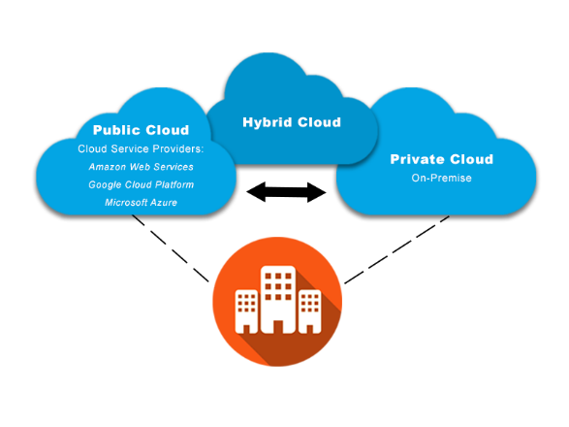

**BENEFITS**

**Reduce time to market**

Enabling cloud solutions to ensure quicker application releases and improve productivity.

**Optimize operations**

Enhancing operational capabilities through an intelligent, automated and self-service approach.

**Maximize business value**

Providing on-demand scalability and reducing total cost of ownership by transitioning to an OpEx model.

**OFFERINGS**

Cognizant’s Hybrid Cloud offers a comprehensive portfolio of components designed to enhance your ability to embrace the cloud and its benefits—accelerating time to market and giving you a significant competitive edge.

**HYBRID CLOUD CORE**

Integrating cloud environments

Cognizant’s Hybrid Cloud core provides a solution architecture for integrating multiple cloud provider environments and technology components. Applications can utilize pooled **resources** across cloud environments and federate across clouds, with the Hybrid Cloud core providing the fabric that makes this possible.

The Hybrid Cloud core provides automated governance across disparate environments and technology components in a complex hybrid cloud ecosystem. It also provides pre-defined domain specific controls such as PCI/HIPAA.

**SECURITY**

**AUTHENTICATE AND AUTHORIZE ACCESS**

Security is a fundamental aspect of Hybrid Cloud. By including the right sets of tools and integrations, the hybrid foundation ensures availability of critical features such as authentication, authorization and granular access control.

Also included are tools that serve as the central point for log aggregation from different sources and alert administrators to the occurrence of any out-of-ordinary event.

The Hybrid Cloud solution provides single sign-on with Enterprise Active Directory and advanced authentication mechanisms such as multifactor authentication and digital rights management (DRM).

**CLOUD MANAGEMENT PLATFORM**

**THE HEART OF HYBRID CLOUD**

Cognizant’s Cloud Management Platform (CMP) offers self-service and brokerage capabilities across clouds. The CMP takes provisioning automation to a new level, with features such as application profile-based provisioning, DevOps integration and configuration automation.

The CMP also provides other insightful features, such as cloud brokerage, capacity management, intelligent workload placement, and lifecycle actions for workloads across clouds.

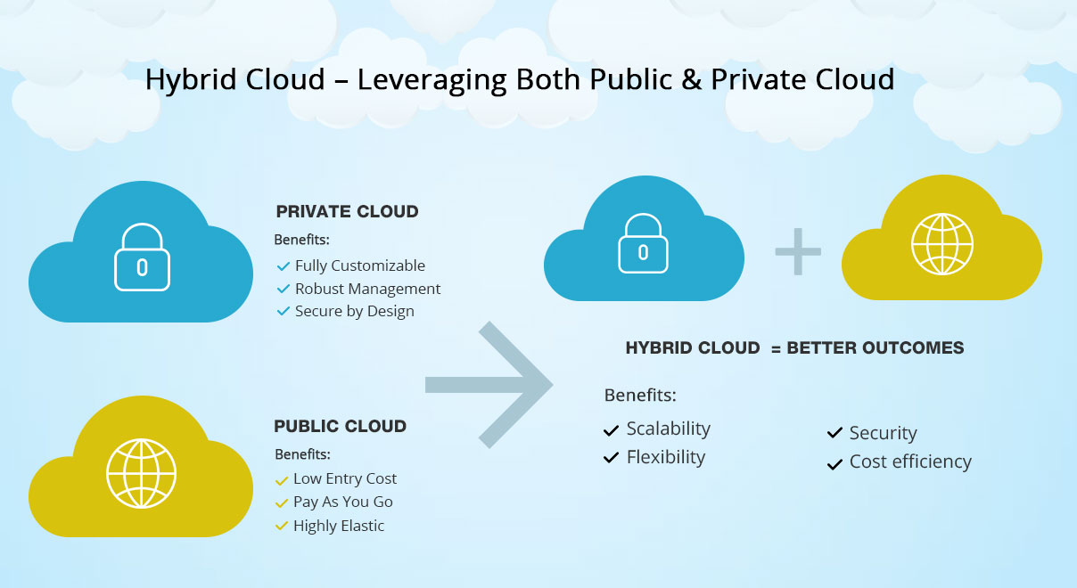

**APPLICATION ONBOARDING**

**ENSURING SMOOTH CLOUD MIGRATION**

The key elements of Cognizant’s approach to Hybrid Cloud are our architecture and transformation blueprints, which present a tested, proven way to adopt hybrid cloud and onboard applications.

Even large IT organizations with varied skillsets are often unable to adopt cloud with optimum speed and certainty. Our application onboarding services ensure a smooth adoption of the Hybrid Cloud, reducing risk and downtime as you migrate to the cloud.

**SERVICE MANAGEMENT**

**END-TO-END MONITORING AND MANAGEMENT**

For effective and automated service management, Cognizant implements a self-service approach to service management with an end-to-end monitoring and performance management architecture that covers everything from applications to infrastructure. Our monitoring framework leverages native public cloud tools as well as third-party monitoring and APM tools.

**DATA PROTECTION AND BUSINESS CONTINUITY**

**LEADING-EDGE BACKUP AND PROTECTION**

Embedded in the Cognizant Hybrid Cloud environment are leading-edge tools for backup and data protection across the cloud, along with information lifecycle management and archival capabilities.

With predefined deployment options for high availability within the site and across sites (a multisite approach), Cognizant’s data protection and business continuity features cover the public cloud and architectures with a multi-region approach.

**THE ADVANTAGES OF HYBRID CLOUD**

Organizations on the path to hybrid cloud can leverage on‑premises private cloud resources

such as compute, storage, database, etc. and tap into the potential of the public cloud, utilizing

the best of both the private and public cloud worlds. Hybrid deployments enable distinct use

cases that are particularly attractive to organizations which want greater choice and agility, but

not at the expense of security or control. Hybrid solutions allow customers to:

• Gain workload portability and flexibility. The ability to easily transport certain workloads

between on‑premises resources and the public cloud provides the agility necessary to

meet the disparate workload requirements that many organizations face — such as web applications that receive maximum user visits during festivals or special offers, and need

additional resources to meet such seasonal demands. Organizations can extend workloads to the public cloud platform to meet spikes, quickly set up dev/test environments, integrate with cloud‑native services and respond more quickly to changing business needs.

• Optimize collaboration across IT teams and business processes. A well‑planned and integrated hybrid infrastructure will increase collaboration by leveraging unified management support. This will enable faster response times to change requests and shorter workload deployment cycles between once‑soloed IT departments and business processes.

• Maintain existing infrastructure while extending to the public cloud platform. An effective hybrid solution will allow organizations to continue to use their existing infrastructure and take advantage of the public cloud for specific requirements such as dev/test, capacity bursting, backup or disaster recovery.

• Consolidate and migrate noncritical workloads to the public cloud platform. Consolidate noncritical workloads that often reside on underutilized IT resources and rely on the public cloud to support them.

**TASK PERFORMED**

**VMWARE TECHNICAL SALES PROFESSIONALS – SERVER VIRTUALIZATION (VTSP-SV)**

**Introduction**

When VMware entered the server virtualization market in 2001, building on the success of VMware Workstation, nobody could have predicted where the innovation based on this technology would lead. Today, Server Virtualization accounts for all cloud-based workloads and nearly all on premise workloads. Virtualization simplified the overhead of traditional IT by allowing application workloads to be encapsulated in software, thus creating a virtual machine. Then, using the vSphere hypervisor, numerous virtual machines could run on top of consolidated groups of powerful servers, called hosts. This radically reduced the size of data centers, simplifying cooling requirements and lowering the overall power consumption for some businesses by up to 90%. An evolving byproduct of virtualization was a new approach to handle both data and uptime of application environments. Grouping hosts into clusters maximized resilience of applications and gave the ability to balance workloads over multiple hosts dynamically.

vSphere is the number one focus: defining the relationship between itself, the applications, and the hardware it utilizes. The functionality that is available through vSphere continues to evolve at a rapid pace, encompassing much more comprehensive offerings around key requirements such as networking, storage, and security. vSphere continues to evolve with the focus on the software-defined enterprise, enabling much of the technology that is foundational to Cloud Computing. In this course, we have learnt about new editions, like the new vSphere Platinum, that shows our continued dedication to enhancing the security of your environment. vSphere allows organizations the flexibility in how they'd build and deploy public and private clouds. Utilizing both, as a hybrid cloud, provides mobile services to both employees and customers and allows for integration with third-party products such as Amazon Web Services. These points of integration support the integration support the new and evolving categories of Cloud Native workloads, like Big Data, while still supporting various x86 server Operating Systems that run a majority of businesses’ mission critical applications. The larger the cloud deployment, the greater the need for a comprehensive management layer to provide automation and operational support. These topics are covered in other courses, but, in this course, we will take a look how they relate to vSphere

**VMware Technical Sales Professional (VTSP)**

VTSP is a free online training program designed to provide Partners with fundamental technical knowledge about VMware vSphere. The goal is to help Partner pre-sales professionals develop the capabilities and gain the confidence to successfully guide customers through product evaluation, selection and installation based on their business requirements and/or existing IT environment.

**Data Center Virtualization and Fundamentals**

**Integrated Architecture Vision**

Customers are telling us that in 2018 they’ll focus on a core set of business outcomes:

• They want to accelerate business agility and innovation.

• Deliver exceptional mobile experiences.

• And of course, they want to protect their brand and customer trust. VMware is helping customers achieve these business outcomes by delivering on customers’ strategic priorities which are modernize data centers, integrate public clouds, empower digital workspaces, and transform security.

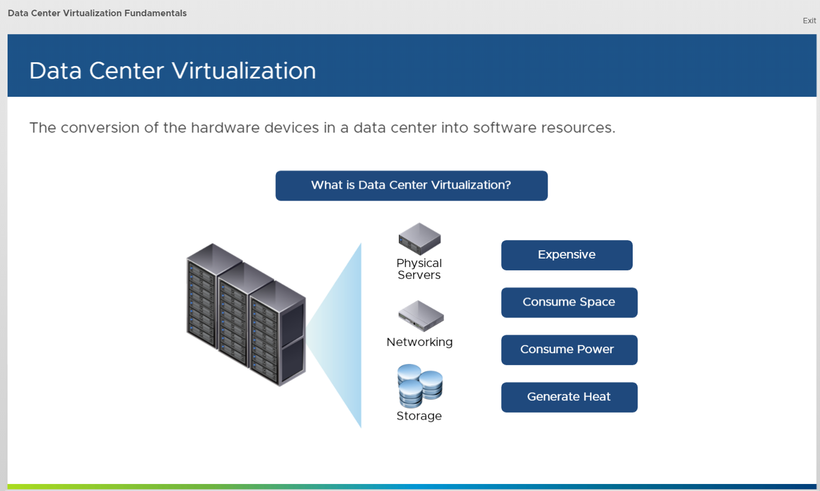

VMware offerings give our customers the flexibility they need now and, in the future, to support their unique business journeys.

• They empower digital workspaces, to enable exceptional mobile experiences.

• They modernize data centers for infrastructure agility, security, and scalability to support business innovation and growth.

• They integrate public clouds to give developers “cloud freedom of choice” while ensuring that their companies use those clouds as effectively as possible.

• And most critically, they transform security so that data, apps, devices, data centers, and clouds are compliant and secure.

**Virtualization Overview**

**Data Center Virtualization**

Data Center Virtualization from a technical perspective, Data Center Virtualization is the conversion of the hardware devices in a data center into software resources. Consider your physical data center which typically includes a number of physical servers, along with other networking, and storage devices. These physical devices are expensive, consume a lot of space and power, and generate heat. Also, hardware failures are always a potential threat and routine maintenance tasks, such as redeployment and backups, are often time consuming processes, requiring extensive downtime. Through Data Center Virtualization, you can consolidate your servers into fewer pieces of hardware and effectively manage them using virtualized management platforms. In a virtualized environment, each server's operating system and applications are separated from the underlying hardware and placed on a hypervisor, which provides each virtual machine access to the underlying physical resources. This enables multiple virtual machines to access the same hardware.

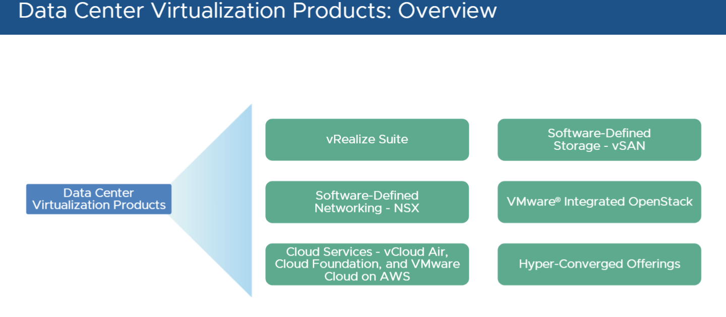

**Introduction to Virtual Machine**

A virtual machine is a software computer that, like a physical computer, runs an operating system and applications. The virtual machine is comprised of a set of specification and configuration files and is backed by the physical resources of a host. Every virtual machine has virtual devices that provide the same functionality as physical hardware and have additional benefits in terms of portability, manageability, and security.

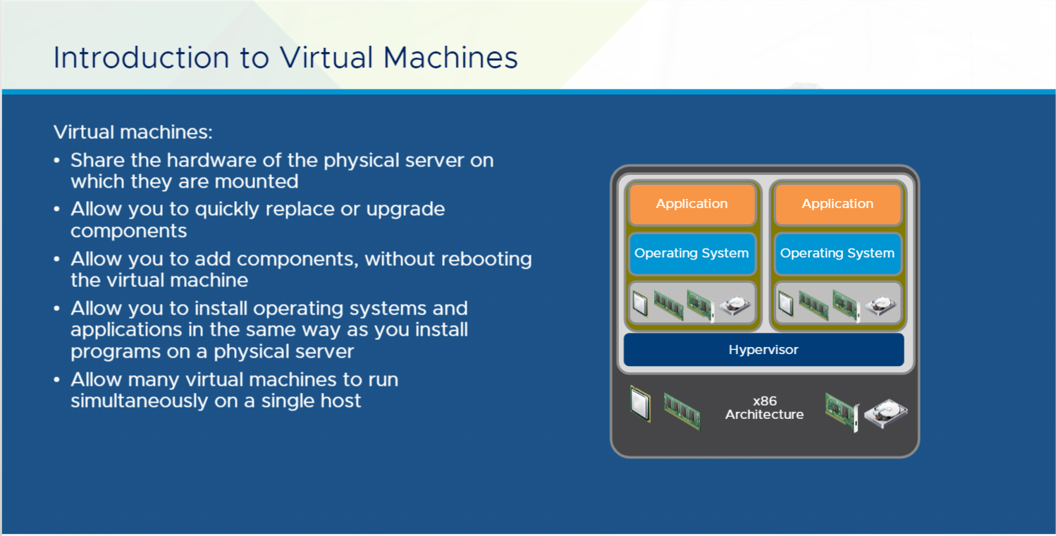

**Benefits of Using VM**

* Multiple OS environments can exist simultaneously on the same machine, isolated from each other;
* Virtual machine can offer an instruction set architecture that differs from real computer's;
* Easy maintenance, application provisioning, availability and convenient recovery.

**Server Virtualization Use Case**

The use cases of Server Virtualization and discover the new features of vSphere 6.7. Virtualization is a proven software technology that makes it possible to run multiple operating systems and applications on the same server at the same time. Virtualization can increase IT agility, flexibility, and scalability while creating significant cost savings. Workloads get deployed faster, performance and availability increase and operations become automated, resulting in IT that's simpler to manage and less costly to own and operate. vSphere powers server virtualization, enabling many use cases. It helps you get the best performance, availability, and efficiency from your infrastructure and applications. It’s the ideal foundation for any cloud environment.

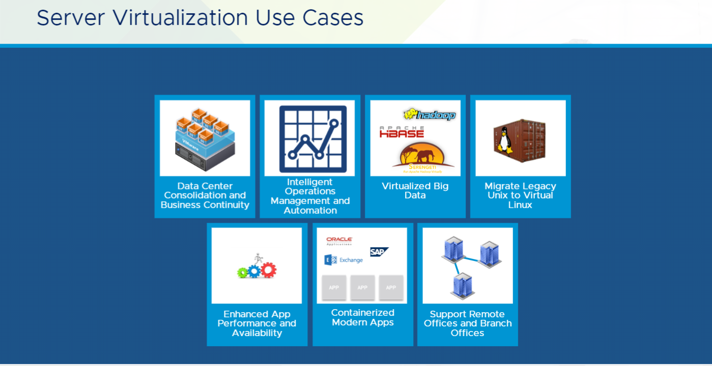

**Server Virtualization**

Server virtualization is driving the digital transformation. It empowers digital workspaces, modernizes data centers, integrates public clouds, and transforms security. This accreditation program explains the fundamentals of server virtualization using vSphere, and the hypervisors and virtual machines that vSphere provides a platform for.

**Overview**

**Reduce IT Costs and Increase Control with Server Virtualization**

Reduce IT costs with server virtualization and consolidation. Eliminate over-provisioning, increase server utilization, centralize server management.

Eliminate over-provisioning, increase server utilization and limit the environmental impact of IT by consolidating your server hardware with VMware vSphere with Operations Management*, VMware's virtualization platform.

Server consolidation lets your organization:

*Reduce hardware and operating costs by as much as 50 percent and energy costs by as much as 80 percent, saving more than $3,000 per year for each virtualized server workload.

*Reduce the time it takes to provision new servers by as much as 70 percent.

*Decrease downtime and improve reliability with business continuity and built-in disaster recovery.

*Deliver IT services on demand, independent of hardware, operating systems, applications or infrastructure providers.

**Reduce Server Costs with Desktop and Server Virtualization**

By consolidating your server hardware with vSphere with Operations Management, your organization can increase existing hardware utilization from as low as 5 percent to as much as 80 percent. You can also reduce energy consumption by decreasing the number of servers in your data center. VMware server virtualization can reduce hardware requirements by a 15:1 ratio, enabling you to lessen the environmental impact of your organization's IT without sacrificing reliability or service levels. Server and desktop hardware consolidation can also help you achieve a 20 to 30 percent lower cost per application, as well as defer data center construction costs by $1,000 per square foot. vSphere with Operations Management allows for a 50 to 70 percent higher virtual machine density per host than commodity offerings.

**Centralize Management of Your Virtual Data Center**

Unlike vendors that only offer single-point solutions for server virtualization, VMware lets you manage an entire virtual data center from a single point of control. With vSphere with Operations Management, you can monitor health, manage resources, and plan for the data center growth all from a unified dashboard.

**Automate the Virtual Data Center**

An automated virtual data center can simplify management while simultaneously delivering performance, scalability and availability levels that are impossible with physical infrastructure. The vSphere with Operations Management platform enables your organization to minimize downtime, enable dynamic, policy-based allocation of IT resources and eliminate repetitive configuration and maintenance tasks.

**CONSOLIDATE**

**Eliminate Over-Provisioning**

**Increase Server Utilization**

Get more out of your existing hardware by consolidating x86 servers with VMware vSphere. In the traditional "one workload, one box" approach to server provisioning, most servers operate at just 5 to 15 percent of their total load capacity, which results in over-provisioning and under-utilization. You can decrease server sprawl and increase utilization by converting your x86 servers into virtual machines that run independently from the underlying hardware.

Each virtual machine represents a complete system that can run Windows, Linux, Solaris and NetWare operating systems and software applications; many virtual machines can run independently on the same physical server at the same time. Running multiple workloads on highly configured x86 servers allows you to increase the utilization of your server hardware from 10 to 15 percent to as much as 80 percent.

**Reduce Hardware Requirements**

Using VMware vSphere with Operations Management*, your organization can reduce the IT hardware in your data center. Each host server running vSphere can support more than 1024 virtual machines. Many organizations run as many as 15 applications on a single piece of hardware, reducing their hardware requirements by a 15:1 ratio.

**Cut Hardware and Operating Costs with Server Consolidation**

Consolidating your hardware means that you need fewer servers in your data center, which means you will spend less on hardware and maintenance and less on energy for power and cooling. VMware virtualization can help your organization save more than $3,000 annually for each server you virtualize.

You can also shift IT resources and budgets away from tactical maintenance to strategic projects. VMware vSphere with Operations Management*, automates and simplifies tedious day-to-day tasks like provisioning, hardware maintenance and performance management. This reduces the cost and complexity of managing IT in your data center.

**MANAGE**

**Managing the Virtual Infrastructure**

VMware gives you the tools to manage and monitor your entire virtual infrastructure from a central location, reduce new server provisioning time and allocate shared IT resources with greater flexibility. VMware works closely with industry-standards organizations and technology partners to ensure seamless interoperability through open interfaces and standards-based technologies.

**Unified Management**

With VMware vSphere with Operations Management*, you can manage all your heterogeneous x86-based operating systems, including Windows, Linux and Netware, by placing them on a single virtual hardware platform. Monitor and analyze virtual machines, resource pools, server utilization and availability with detailed performance graphs. Define the performance metrics that are important to you at the specific levels you need and view them in real time or across a specified time interval.

**Accelerate Provisioning Time**

With vSphere with Operations Management, you can create templates for your virtual machines, thus eliminating repetitive installation and configuration tasks when provisioning new server workloads. When coupled with the hardware independence of virtualization, you can reduce the time it takes to deploy new IT services by 50 to 70 percent. Virtual machine templates also make it easier to enforce corporate standards for anti-virus and management software.

**AUTOMATE**

**Automate IT to Maximize Efficiency in Your Data Center**

With VMware vSphere with Operations Management*, you can deliver on demand IT resources wherever and whenever they are needed. This allows you to dynamically allocate and balance computing capacity and virtual machine placement across the data center.

You can transform your IT infrastructure into a responsive, self-optimizing data center with vSphere's built-in capabilities for resource optimization, application availability and operational automation. vSphere with Operations Management supports IT environments of any size and is not tied to any operating system, giving you a bias-free choice of operating system and software applications.

**Enable Live Virtual Machine Migration**

vMotion, part of vSphere, enables you to migrate virtual machines from one physical server to another with zero downtime, continuous service availability and complete transaction integrity. Live virtual machine migration allows you to perform hardware maintenance without scheduling downtime or disrupting business operations.

**Deliver Mission-Critical Services On Demand**

Balance computing capacity across the resource pools in your virtual infrastructure. vSphere DRS continuously monitors storage, CPU and RAM utilization, automatically reallocating available resources based on pre-defined policies that reflect your organization's business needs and priorities. The end result is a data center that can run at more than 80 percent utilization while maintaining guaranteed service levels for all applications. VMware delivers much better ROI on x86 server investments with minimal capacity planning.

**VSphere 6.7**

vSphere 6.7 is the next- generation infrastructure for next-generation applications. It provides a powerful, flexible, and secure foundation for business agility that accelerates the digital transformation to cloud computing and promotes success in the digital economy. vSphere 6.7 supports both existing and next- generation apps through its simplified customer experience for automation and management at scale; comprehensive built-in security for protecting data, infrastructure, and access along with universal application platform for running any app, anywhere. With vSphere 6.7, customers can now run, manage, connect, and secure their applications in a common operating environment, across clouds and devices. vSphere 6.7 provides a highly available, resilient, on-demand infrastructure that is the ideal foundation of any cloud environment. As the ideal platform for apps, cloud, and business, vSphere 6.7 reinforces the customer’s investment in VMware. vSphere 6.7 is one of the core components of software-defined data center of VMware and a fundamental building block for cloud strategy of VMware. It also helps free up time, so you can focus on more strategic tasks by safely automating workload placement and resource optimization on your terms, with increased control based on pre-set, customizable templates.

VSphere editions

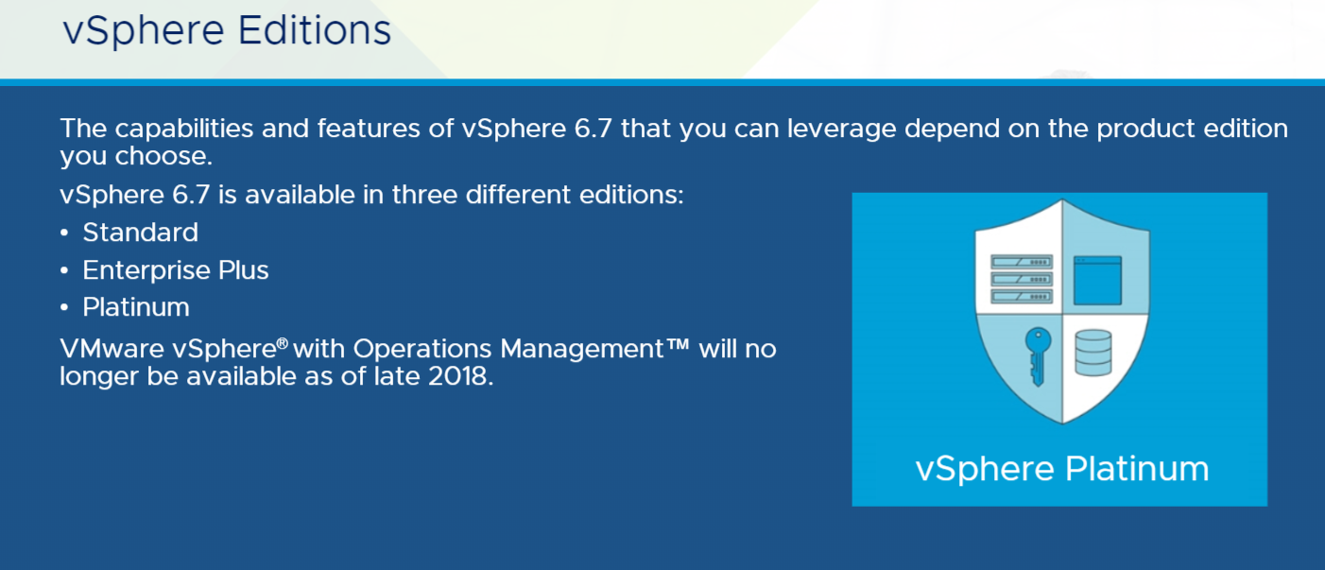

**components of vSphere**

components of vSphere, as well as various products that leverage the power of virtualization to transform data centers into simplified cloud computing infrastructures and enable IT organizations to deliver flexible and reliable IT services.

**Migration tool**

A feature in vSphere 6.7 has the ability to migrate a Windows vCenter Server 6.0 or 6.5 to vCenter Server Appliance 6.7. There are two processes involved in migration. The first process pre-checks the source Windows vCenter Server 6.0 or 6.5 to determine if it meets the criteria to be migrated. The second is the data transport mechanism that migrates data from the source Windows vCenter Server 6.0 or 6.5 to the target vCenter Server Appliance 6.7. During the migration process, the vCenter Server configuration, inventory, and alarm data are migrated by default.

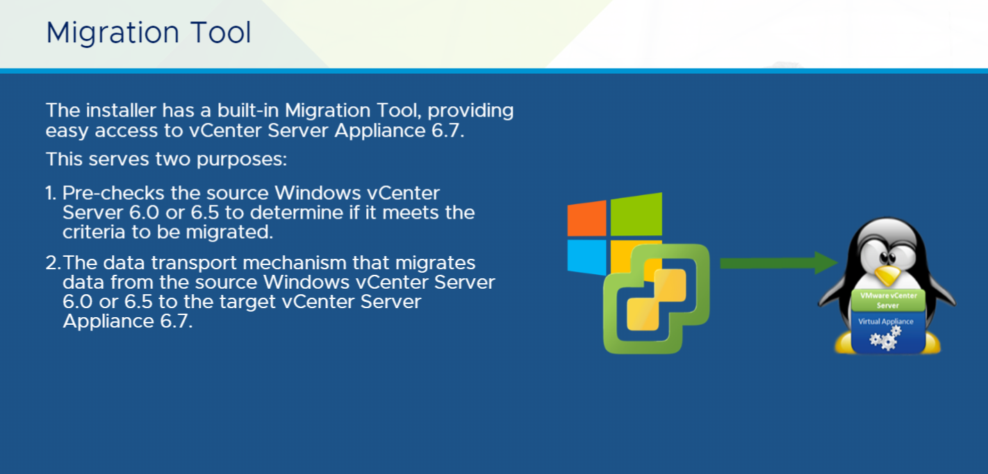

**vSphere vMotion**

vSphere vMotion allows you to migrate a running virtual machine from one ESXi host to another without any downtime. You can also change both the host and the datastore of the virtual machine during vSphere vMotion. When you migrate virtual machines with vSphere vMotion and choose to change only the host, the active memory and precise execution state of the virtual machine is rapidly transferred to the new host. vSphere vMotion suspends the source virtual machine, copies the bitmap to the new ESX host, and resumes the virtual machine on this new host. The associated virtual disk remains in the same location on storage that is shared between the two hosts. Only the RAM and the system state are copied to the new host. When you change both the host and the datastore, the active memory and precise execution state of the virtual machine is moved to a new host and the virtual disk is moved to another data store. vSphere vMotion migration to another host and data store is possible in vSphere environments without shared storage.

The different types of vSphere vMotion include:

**Encrypted vSphere vMotion** secures confidentiality, integrity, and authenticity of the data that is transferred with vSphere vMotion.

**Cross vSwitch vSphere vMotion** allows you to seamlessly migrate a virtual machine across different virtual switches while performing a vSphere vMotion.

**Cross vCenter vSphere vMotion** has the ability to migrate a virtual machine from a host server that is managed by one vCenter Server to a host managed by another vCenter Server.

**Long Distance vSphere vMotion** allows you to migrate virtual machines across a WAN to another site. The latency across sites is 150 ms round-trip time or RTT.

**VMware Cloud on AWS vSphere vMotion** supports bi-directional application migration with consistent policies using vSphere vMotion between on-premises data centers and the AWS Cloud.

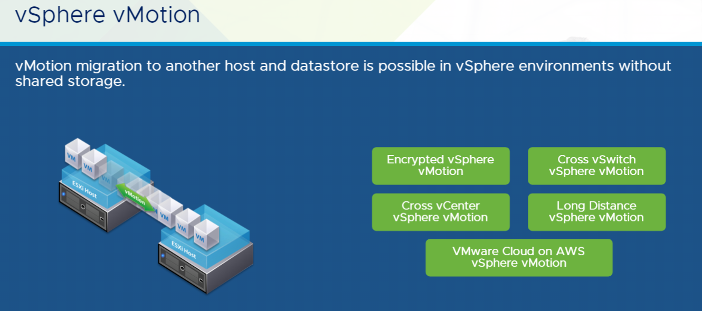

**vRealize Suite**

vRealize Suite is a cloud management platform purpose-built for the hybrid cloud. It delivers and manages infrastructure and applications quickly while maintaining IT control. vRealize Suite provides a comprehensive management stack for IT services on vSphere and other hypervisors. It extends a unified management experience to external cloud service providers such as vCloud Air and AWS or OpenStack-based private and public clouds. With vRealize Suite, businesses get the agility and speed needed to maintain competitive advantage. At the same time, IT gets the control and efficiency needed to manage uptime, performance, compliance, and cost of infrastructure and applications.

vRealize Suite consists of:

• vRealize Automation

• vRealize Operations

• vRealize Log Insight

• vRealize Business

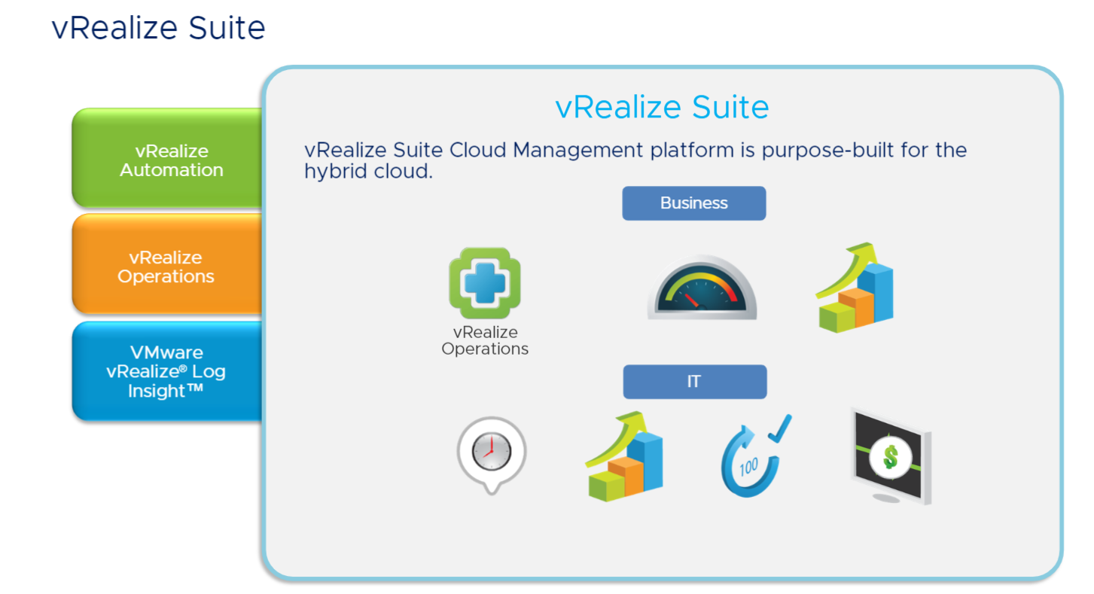

**SECURITY REQUIREMENT FOR MODERN DATA CENTERS**

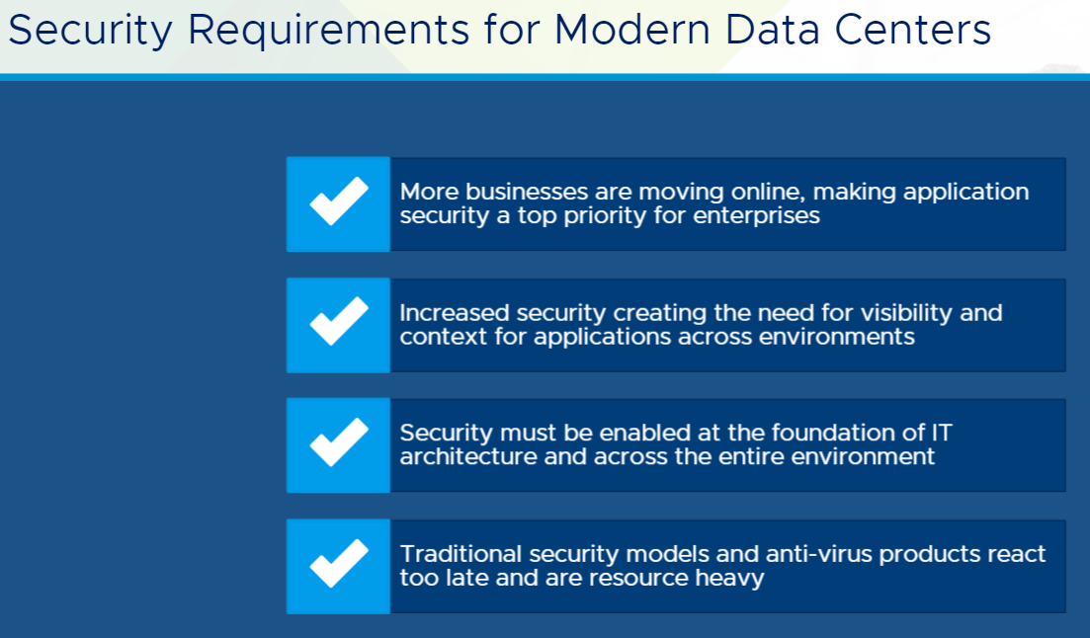

**VMWARE TECHNICAL SALES PROFESSIONALS – MANAGEMENT AUTOMATION (VTSP-MA)**

**vRealize Automation:**

Increase Productivity and Reduce Costs Through Automation

vRealize Automation speeds up the delivery of infrastructure and application resources through a policy-based self-service portal, on-premises and in the public cloud.

IT organizations are constantly under pressure to become more agile and enable the ever-changing business needs. vRealize Automation can help by automating manual processes and speeding up the delivery of IT services and applications. With vRealize Automation, IT teams can increase developer and IT productivity, reduce costs and maintain high level of governance and control.

**AT A GLANCE:**

VMware vRealize® Automation™, part of VMware vRealize Suite, empowers IT to accelerate the provisioning and delivery of IT services, across infrastructure, containers, applications and custom services. Leveraging the extensible

framework provided by vRealize Automation, you can streamline and automate the lifecycle management of IT resources from initial service model

design, through Day One provisioning and Day Two operations. Whether your IT services are running on private cloud, public cloud or hybrid cloud, the multivendor, multi-cloud solution supported by vRealize Automation assures your services will be delivered with speed,control and performance.

**KEY BENEFITS**

• Agility – Automate IT service delivery processes (infrastructure, containers, applications, and any custom IT service) to rapidly respond to business needs

• Extensibility – Easily integrate with third-party tools across IT ecosystem to protect investments in existing and future technologies

• Control – Embed governance-based policies into IT services across a hybrid cloud environment to ensure compliance, performance and financial outcomes

• Choice for Developers – Enable self-service that can rapidly deliver

building blocks to developers

• Complete lifecycle management – Achieve optimal workload management

from initial deployment, on-going rebalance, to retirement and reclamation using the vRealize Suite

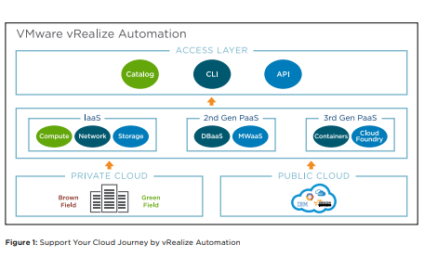

**What Does VMware vRealize Automation Deliver?**

IT Automation: VMware vRealize Automation delivers Day One service provisioning and Day Two operational capabilities across a hybrid cloud. These capabilities help IT organizations automate core IT processes; speed up infrastructure delivery, and get the most out of both hardware and people resources.

• Service Delivery Automation: Automate the provisioning of all infrastructure components, including compute, network, storage and security resources.

• Infrastructure Lifecycle Management: Manage infrastructure resources from a single solution throughout their entire lifecycle, including initial deployment, resizing, reclamation and retirement.

• Cross Cloud IT Automation: Support workloads provisioning and deployment both on premises and on public clouds with unified governance and management.

• Integration with IT Ecosystem: Extend automation across IT ecosystem by integrating with prevailing third-party tools through a full spectrum of extensibility options. VMware vRealize Automation gives IT teams the ability to provide developers easy access to traditional and cloud native application resources through a rich set of self-service capabilities while simultaneously supporting the need for developers to use the tool chain of their choice.

• Infrastructure as a Service: Enable a self-service model that gives developer easy access to infrastructure services through catalogs, API or CLI.

• Support for 2nd Generation Applications: Out-of-the-Box integration with Puppet leveraging a framework for integrating configuration management tools that simplifies the delivery and management of 2nd generation application stacks.

• Support for Cloud Native Applications: Discover and manage container hosts and containers through embedded a container management platform that supports VMware vSphere® Integrated Containers™ and Docker. This approach supports the design of mixed mode applications blueprints that contain both VMs and Containers.

**Key Features**

**Deliver a Self-Service Experience**

• Unified IT service catalog – deliver infrastructure, container, application and custom services (XaaS).

• Policy-based governance ensures the right service level to meet specific business needs.

• Automation accelerates IT service delivery.

**Unified Blueprint Model via Design Canvas, Command Line or API**

• Streamline IT service design process by assembling applications from prebuilt components using a visual canvas with a drag and drop interface.

• Blueprints as Code - Export, import and edit automation blueprints as text. • API – enable the entire design and management process via API calls.

• Leverage VMware and partner-provided blueprints in VMware Cloud Management Marketplace. Deploy Across Multi-Vendor, Hybrid Cloud Infrastructure

• Flexibility to choose the right cloud platform and location that meets the business needs.

• Consistent governance and control across hybrid cloud deployments.

**Accelerate Time to Value via an Extensible Automation Platform**

• Extensible platform that enables customization and extensibility at multiple levels across IT ecosystem.

• Design and automate the delivery of any IT services (XaaS) through service orchestration.

• Leverage VMware and partner-provided integration solutions in VMware Cloud Management Marketplace.

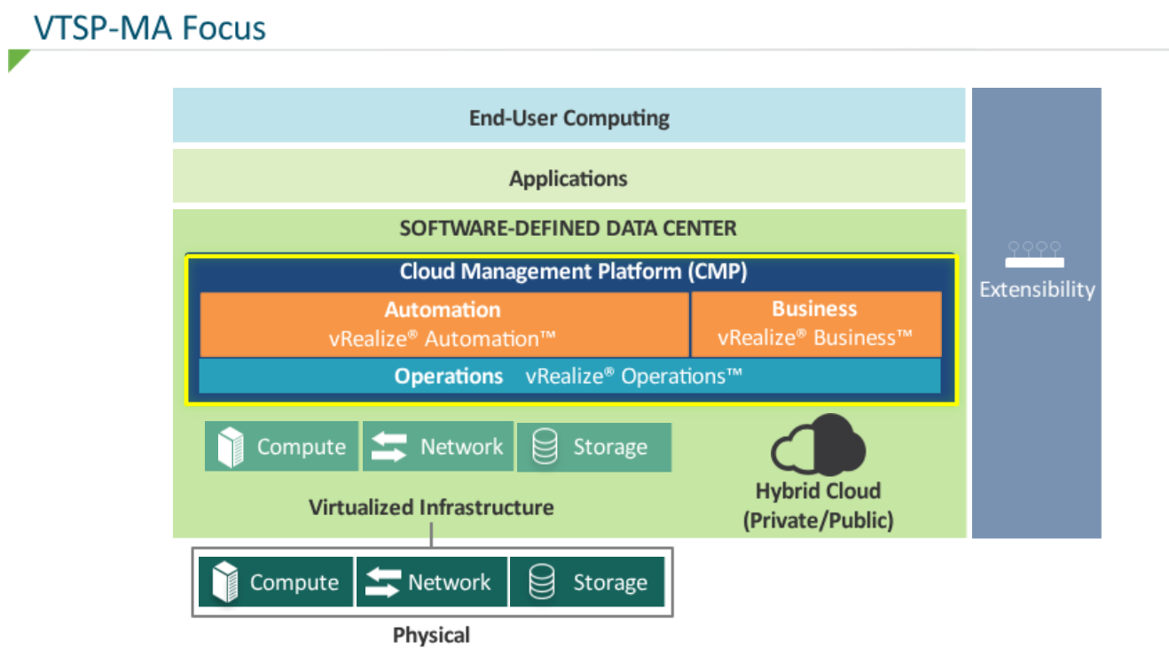

**VMWARE vREALIZE BUSINESS FOR CLOUD**

Automated Management for Cross-Cloud Costing, Consumption, Comparison, and Planning

**Introduction**

VMware vRealize® Business™ for Cloud is a cloud business management solution for IT infrastructure and operation teams that helps IT deploy and manage hybrid cloud environments more efficiently. The automated costing analysis, consumption metering, cloud comparison, and planning capabilities in vRealize Business for Cloud provide an easy way for IT teams to understand their IT costs, communicate effectively with their business counterparts around these costs, and be able to plan better for future IT spending.

**KEY BENEFITS**

• Rapid time to value – Automated data collection and instant cost analysis across hybrid cloud environments

• Cloud cost management in one place – Operational and cost visibility for private and public clouds in a single dashboard

• Fast cost allocation – Quick understanding of which business groups, applications, and services are using cloud services and how much they are using

• Cloud spend optimization – Easy identification of areas to improve, including resource management and sourcing

• Best for Software-Defined Data Center – Seamless integration with VMware vCenter® and other vRealize solutions

**USE CASES**

**Cloud Cost Management**

Track private and public cloud costs in a single dashboard, providing a simple-to-interpret view of cost drivers and spending efficiency. IT organizations can automatically and continuously track the cost of on-premises vSphere virtual infrastructure, as well as easily assess business spending across multiple public cloud providers and accounts.

**Cloud Consumption Analysis and Show back**

IT organizations get visibility towards the business groups, applications, and services that are consuming the most and least enterprise infrastructure. IT teams can securely share cloud services allocation statements, show back reports with specific LOBs through role-based access. With monthly charge projections and budget tracking, the solution provides greater transparency across the business.

**Cloud Comparison and Planning**

Automating cost comparisons on current and planned workloads helps IT organizations quickly evaluate cloud options.. IT teams can compare public and private cloud costs to make smarter cloud purchasing decisions. The solution also provides procurement planning capability to help IT teams improve resource management.

**Features**

Automatic private cloud metering, costing, and pricing

Private cloud consumption analysis

Private cloud and public cloud cost comparison

Out-of-the-box hybrid cloud assessment (Comprehensive cloud costing and business assessment)

Automatic reporting, custom reporting and API for data extraction

Data center optimization (Integrated with vRealize Operations)

Identifying and quantifying private cloud reclamation opportunities (Integrated with vRealize Operations)

Procurement planning

Public cloud costing, consumption analysis, and pricing

Role-based show back

Automatic service catalog pricing (Integrated with vRealize Automation)

## **vRealize Automation 7.0: Simplified Configuration Process**

You’ll notice improvements right away, as the installation wizard greatly reduces the time it takes to get things up and running. With the minimal deployment option, you can be up and running 6 times faster than with previous deployments. The helpful guide allows you to configure your system precisely the first time for the type of deployment that you want. The simplified architecture, including authentication and Single Sign-On, in [vRealize Automation 7.0](https://www.vmware.com/products/vrealize-automation?src=so_5703fb3d92c20&cid=70134000001M5td) bring ease to this process, enabling you to begin provisioning services in a fraction of the time this used to take.

[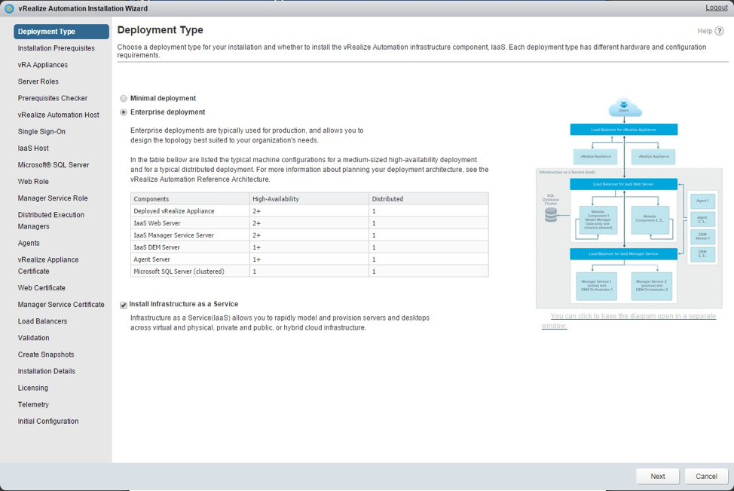](http://blogs.vmware.com/management/files/2015/10/installwizard.png)

**Unified Service Blueprint and Design Canvas**

[vRealize Automation 7.0](https://www.vmware.com/products/vrealize-automation?src=so_5703fb3d92c20&cid=70134000001M5td) boasts a new unified service blueprint and design canvas. Component services like compute infrastructure, networks, security and software can be intuitively assembled with a simple move of your mouse.

[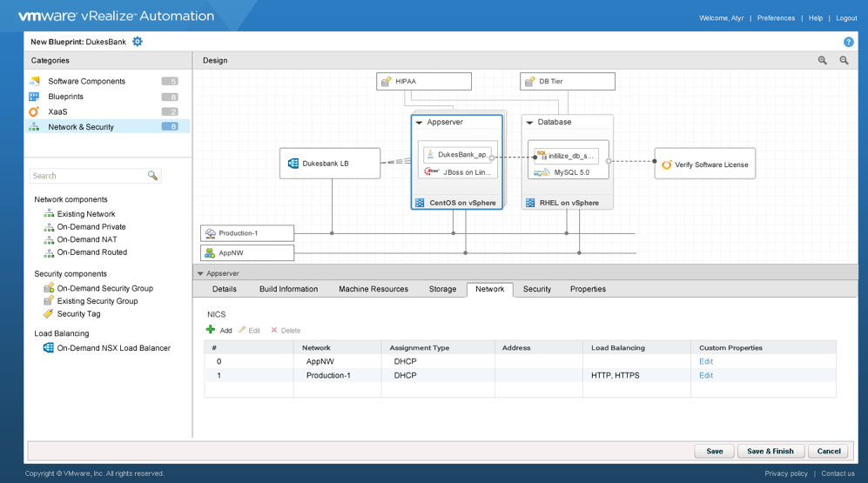](http://blogs.vmware.com/management/files/2015/10/BP-Canvas.png)

## **Network and Security**

Dynamically configure NSX logical services to meet the needs of each application by using the same drag-and-drop interface. This greatly simplifies the process of designing application workloads with appropriate network connectivity, security, availability, scale and performance. This also eliminates the need for networking to be provisioned as a separate activity outside of vRealize Automation 7.0.**[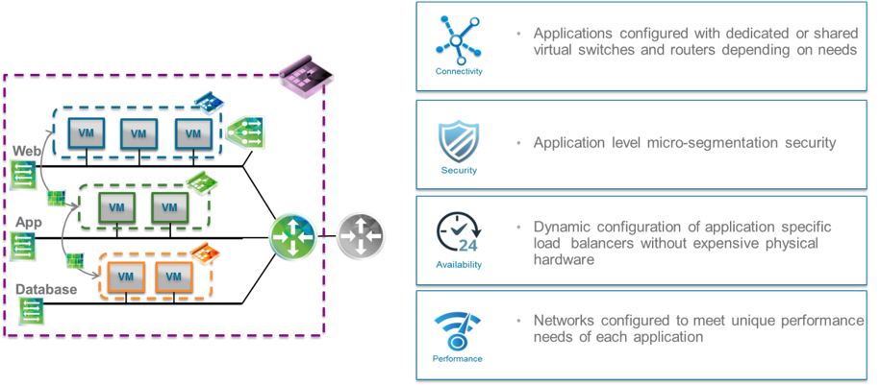](http://blogs.vmware.com/management/files/2015/10/Network-and-Security.png)**

**Blueprint as Code**

Additionally, service blueprints can be edited as text files to facilitate DevOps deployments. The ability to export and import blueprints as code improves

[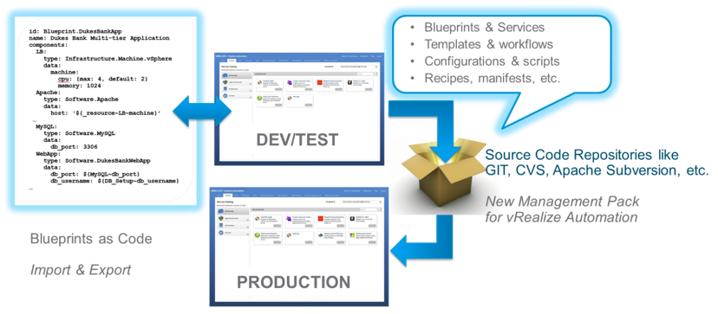](http://blogs.vmware.com/management/files/2015/10/BP-as-Code.png)

## **Improved Extensibility**

[vRealize Automation 7.0](https://www.vmware.com/products/vrealize-automation?src=so_5703fb3d92c20&cid=70134000001M5td) also features enhanced extensibility, to simplify and expand the ability to invoke external tools and integrate with existing systems. We have added a new Event Broker that simplifies and standardizes the process by which 3rd party solutions integrate with vRealize Automation. This helps ensure that the solution can be easily upgraded. We have also improved the API experience for users that prefer to access capabilities of vRealize Automation via an API. And finally, expanded hybrid cloud support means users get the best of both public and private cloud, including AWS and vCloud Air Government Clouds.

## 

[vRealize Automation 7.0](https://www.vmware.com/products/vrealize-automation?src=so_5703fb3d92c20&cid=70134000001M5td) accelerates business to save you time and money.

* Understand the Proven Savings, [Download the Forrester Report: Total Economic Impact of VMware Automated Application Deployment](http://info.vmware.com/content/vRealize-infographic-33988?touch=1&src?src=so_5703fb3d92c20&cid=70134000001M5td).
* [Register here](http://eepurl.com/bzuYHD) to be notified as soon as the product download becomes available.
* For additional vRealize Automation, information visit our[product page.](https://www.vmware.com/products/vrealize-automation?src=so_5703fb3d92c20&cid=70134000001M5td)

**Cloud Management platform**

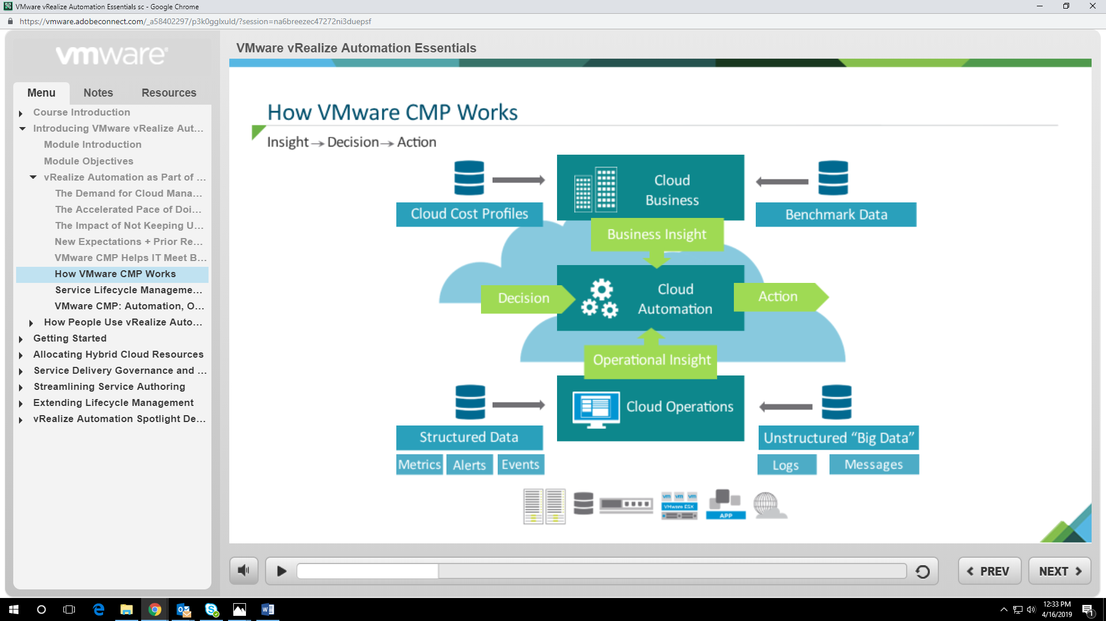

**New Features in vRealize Automation Since Release 6.2 1**

vRealize Automation 7.0 and later includes several architectural changes that simplify configuration and deployment.

**Architectural Changes**

The appliance database is now clustered automatically within the appliance. There is no longer any need for an external database load balancer or DNS entry. Detection of the master database server is handled internally within the appliance. Manual failover is still required and can be performed from the Virtual Appliance Management Console. n The instance of vRealize Orchestrator is now clustered automatically within the appliance. In 7.0 and later, you can use the instance of vRealize Orchestrator within the vRealize Automation appliances when they are configured in a highly-available manner. n Authentication is now handled by an embedded instance of VMware Identity Manager, known as Directories Management, within vRealize Automation. There is no longer a requirement to deploy an Identity Appliance, vCenter SSO or Platform Services Controller. n vRealize Application Services functionality has been merged into vRealize Automation. The vRealize Application Services appliance no longer exists.

**Deployment Changes**

vRealize Automation deployments require two less load balanced endpoints as there is no need to balance the appliance database and an external SSO provider. n Four virtual machines can potentially be removed from the footprint for most deployments, though an external vRealize Orchestrator instance is still recommended for some situations.

**HANDS ON LAB**

**BIBLIOGRAPHY**

* https://pypi.org/project/pytesseract/
* https://medium.com/@mindfiresolutions.usa/advantages-and-disadvantages-of-python-programming-language-fd0b394f2121
* https://www.w3schools.com/python/
* https://www.analyticsvidhya.com/blog/2017/01/ultimate-guide-to-understand-implement-natural-language-processing-codes-in-python/
* https://www.analyticsvidhya.com/blog/2018/02/natural-language-processing-for-beginners-using-textblob/
* https://www.datacamp.com/community/tutorials/web-scraping-using-python
* https://www.tutorialspoint.com/excel

**CERTIFICATIONS**